Mi Gao

CPS 420

Web Framework Project

I design a web framework which is an online blog for who may want to track some private diaries or articles and do not like to show on the large open company’s site. Also, users can sort their papers by the tags; linking to some other pages; and more things are being designed such as the calendar or the thermometer.

The language I Implemented for this framework is Django which based on Python; and the development tool is Pycharm. Django is a high-level Python Web framework that encourages rapid development and clean, pragmatic design. Built by experienced developers, it takes care of much of the hassle of Web development, so you can focus on writing your app without needing to reinvent the wheel. Also, it is important that It is free and open source.

Also, I use Bootstrap as the front-end web framework include HTML, jQuery, and CSS. Bootstrap is a free and open-source front-end web framework for websites and web applications. It contains HTML- and CSS-based design templates for typography, forms, buttons, navigation and other interface components, as well as optional JavaScript extensions. Many other web frameworks, it reviews their with front-end development only.

The database I choose to use PostgreSQL. PostgreSQL, often simply Postgres, is an object-relational database (ORDBMS) – i.e. an RDBMS, with additional (optional use) "object" features – with an emphasis on extensibility and standards compliance. As a database server, its primary functions are to store data securely and return that data in response to requests from other software applications. It can handle workloads ranging from small single-machine applications to large Internet-facing applications (or for data warehousing) with many concurrent users; on macOS Server, PostgreSQL is the default database; and it is also available for Microsoft Windows and Linux (supplied in most distributions). PostgreSQL is developed by the PostgreSQL Global Development Group, a diverse group of many companies and individual contributors. It is free and open-source software, released under the terms of the PostgreSQL License, a permissive free-software license.

Moreover, I finally found a free server which was called Herokuapp. Heroku is a cloud Platform-as-a-Service (PaaS) supporting several programming languages that is used as a web application deployment model. Heroku, one of the first cloud platforms, has been in development since June 2007, when it supported only the Ruby programming language, but now supports Java, Node.js, Scala, Clojure, Python, PHP, and Go. For this reason, Heroku is said to be a polyglot platform as it lets the developer build, run and scale applications in a similar manner across all the languages. Heroku was acquired by Salesforce.com in 2010 for $212 million. The Heroku platform automatically routes HTTP requests sent to your app’s hostname(s) to your web dynos. The entry point for all applications on the Common Runtime stack is the herokuapp.com domain which offers a direct routing path to your web dynos.

Although at the beginning, I wanted to use ASP.NET to design this project, I found I did not have enough knowledge and time to complete what I really want to get because of the limited time and ability. I may be going to keep explore these after this semester.

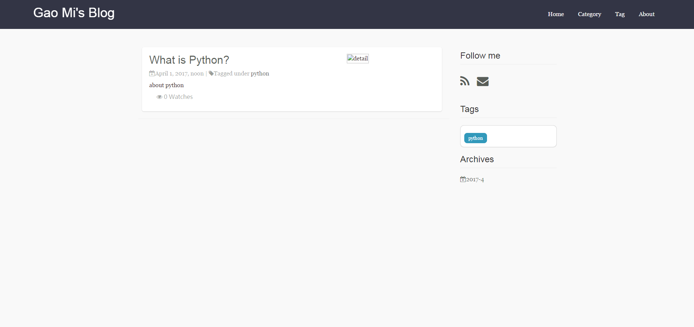 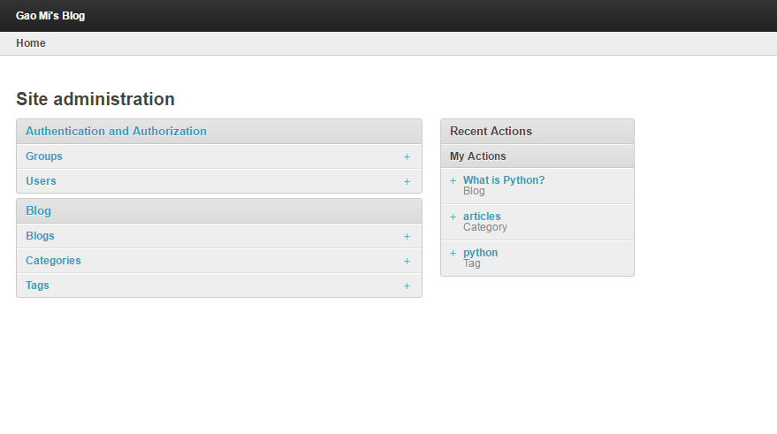 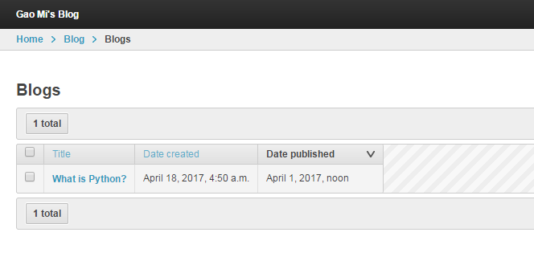 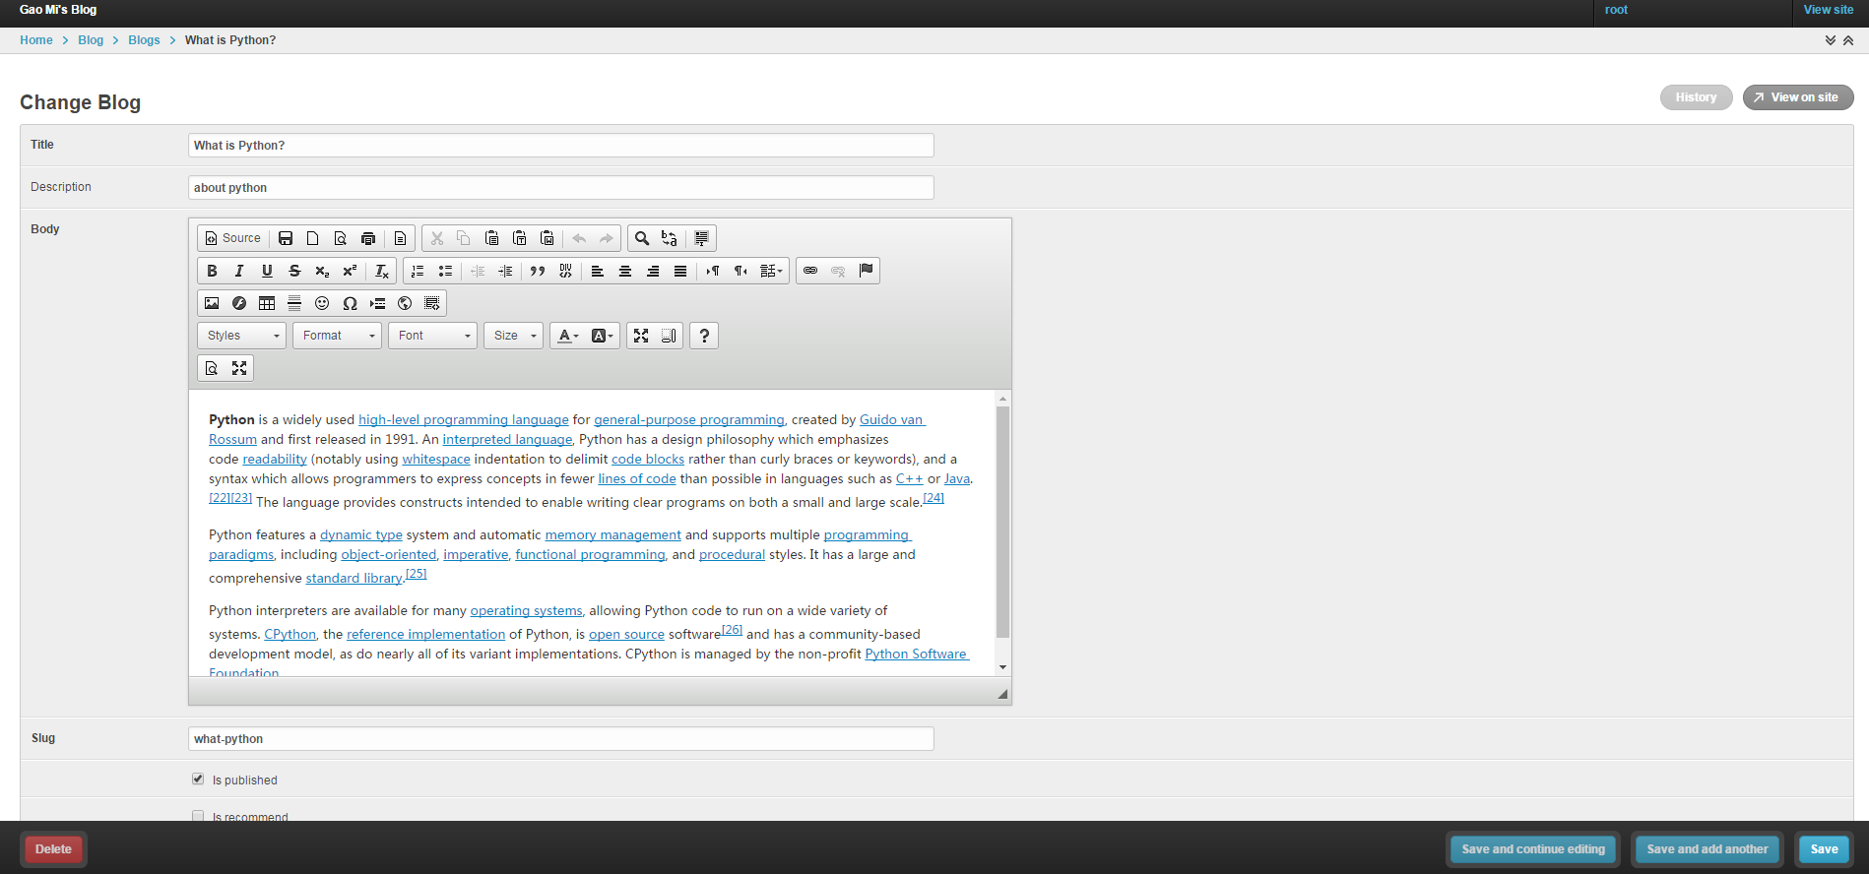

References

Django, retrieve from <https://www.djangoproject.com/>

Bootstrap, retrieve from <https://en.wikipedia.org/wiki/Bootstrap_(front-end_framework)>

PostgreSQL, retrieve from <https://en.wikipedia.org/wiki/PostgreSQL>

Herokuapp, retrieve from https://devcenter.heroku.com/